

**Tech Hub**

Project Final Report

Fall 2016

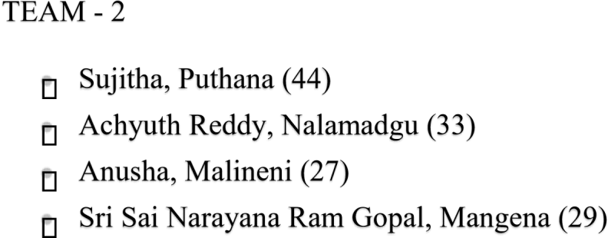

**Table of Contents**

1.Introduction 3

2. Project Deployment & Project Management 4

2.1 Login Page 4

2.2 Registration Page 5

2.3 User Registering 6

2.4 Home page 7

2.5 Dynamic search for videos and wiki 8

2.6 Implementing You tube API 9

2.7 Implementing WIKI API 10

2.8 Detail View of WIKI 11

2.9 Home menu 12

2.10 Profile Details of User 13

2.11 Coursera API 14

2.12 Implementing Courera API 15

2.13 Results of the API 16

2.14 Technical Events near by 17

2.15 Implementing Eventful API 18

2.16 Results of API 19

2.17 Discussion Forum 20

2.18 Creating a topic 22

2.19 Adding comment to existing thread 25

2.20 Search functionality in discussion forum 27

2.21 Feedback Page 28

2.22 Settings 30

3. Project proposal 35

4. Project plan 37

4.1 Class Diagram 37

4.2 Use case Diagram 38

4.3 Sequence Diagram 39

4.4 Architecture Diagram 40

5. First Increment Report 40

6. Second Increment Report 41

7. Third Increment Report 41

8. Fourth Increment Report 42

9. Project Management 44

10. Future Work 45

11. Bibliography 46

**1. Introduction**

# Tech Hub

The Advancement in the feather of Computer Science had improved immensely in the last decade, as its seeds sowed with 1’s and 0’s and now engineers with integration of 1’s and 0’s made many software applications to resolve complex things easily. This project is an attempt to make all the technical stuff available to students at a single point. Our main aim is to develop an application where a user can access all types of resources like wiki pages, videos, online courses, events and can discuss about any technical issues with other members of the application.

**2. Project Deployment & Project Management**

**Application:**

2.1 Login page for the application “Tech Hub” as shown below:

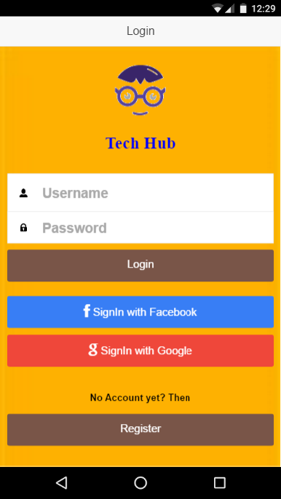

2.2 A new user can register by clicking on ‘No account yet? Create one’ button. By clicking on this button, application will be redirected to registration page.

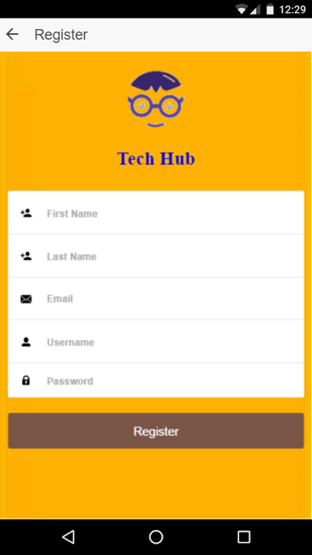

2.3 User must enter name, email id, password and confirm password fields to complete the registration.

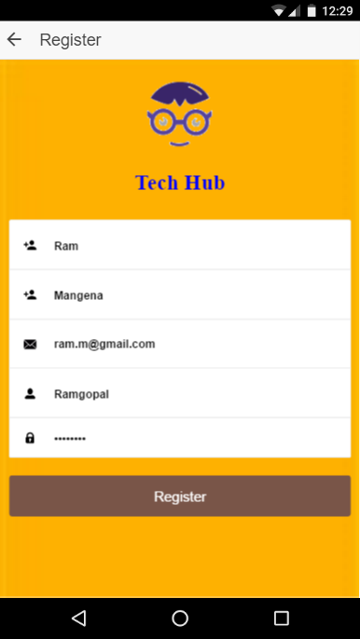

2.4 Following is the home page of our application. User will be redirected to home page by logging into the system either through application login or through Facebook login.

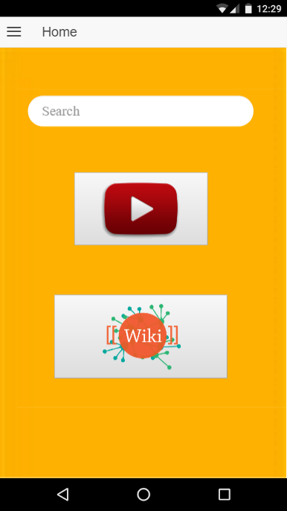

2.5 User can search for any technology on home page by giving the search string in the provided textbox.

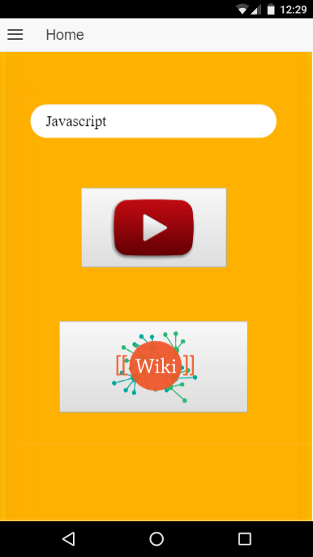

2.6 By clicking on video, results related to videos will be displayed.

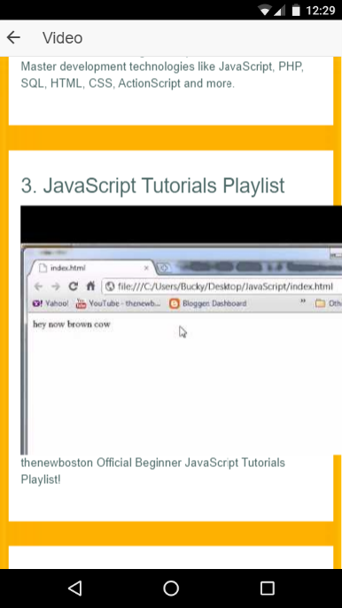

2.7 By clicking on wiki search, user will be redirected to a page with wiki results.

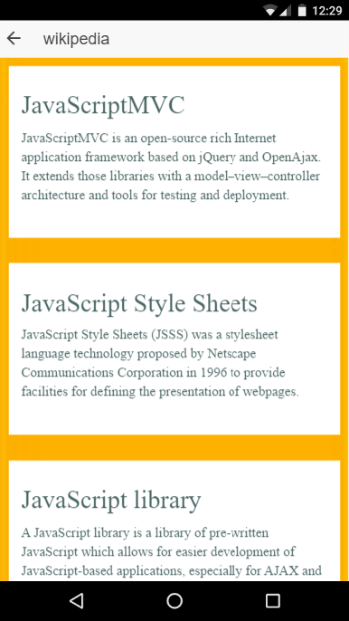

2.8 By clicking on any wiki link, corresponding wiki page will be displayed.

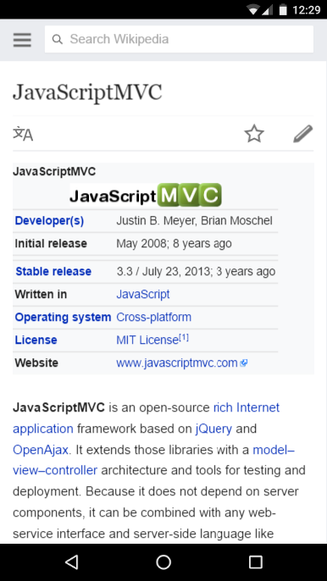

2.9 This is the side menu of our application.

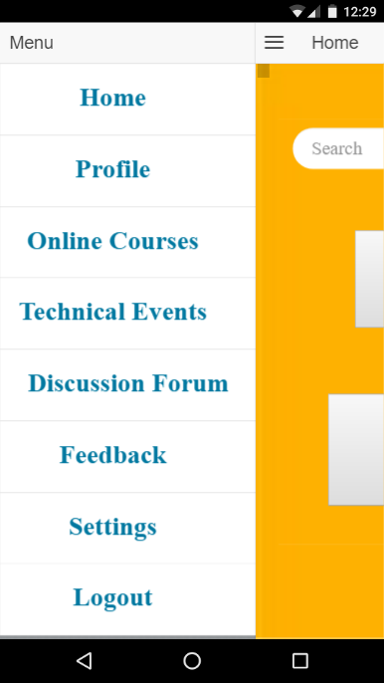

2.10 By clicking on profile, user details will be displayed.

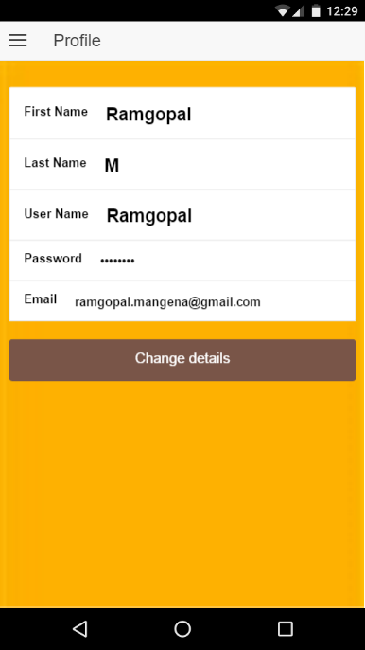

2.11 By clicking on ‘online courses’ button from side menu, courses home page will be displayed.

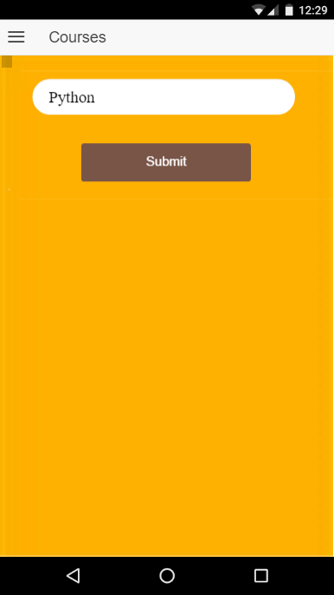

2.12 User can give any search string and corresponding courses will be retrieved from coursera website.



2.13 Following are the search results for the word ‘python’. Our application will display all available courses related to python from coursera website.

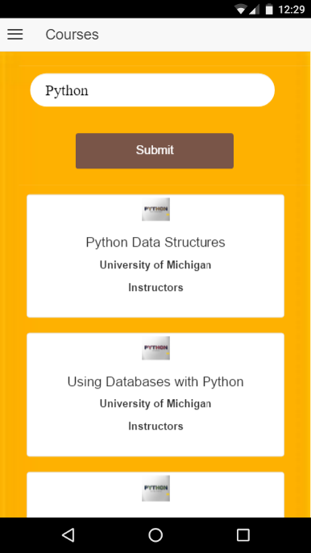

2.14 By clicking on ‘Technical events’ button on side menu, user will be redirected to a page that will provide all the technical events in the given area.

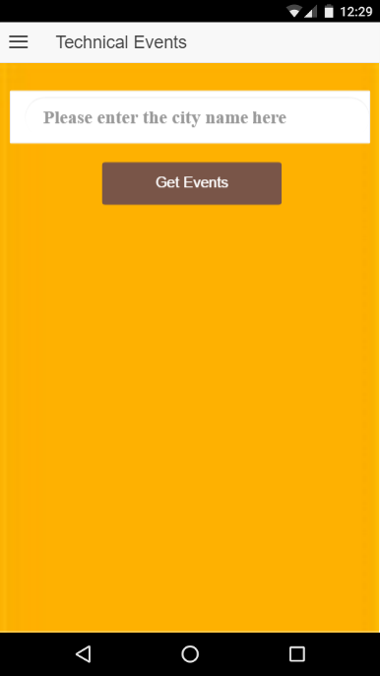

2.15 Following screenshots refers the search results for the key word ‘bay area’. Our application retrieves all the technical events from the given area.

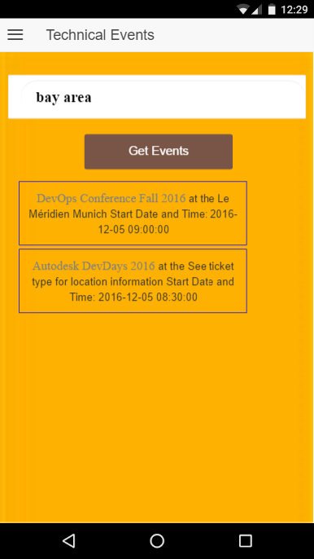

2.16 Following image corresponds to the event search results for another area.

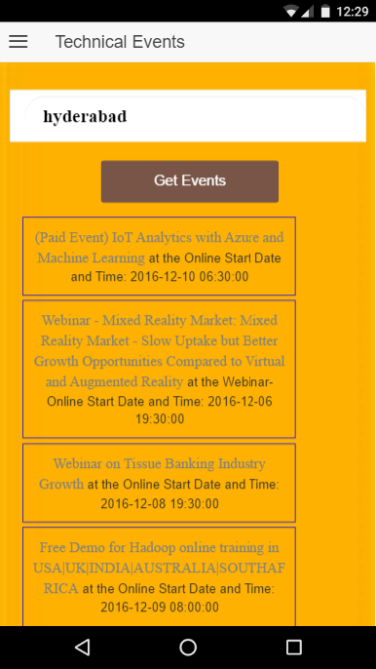

2.17 By clicking on ‘discussion forum’ user will be redirected to discussion forum, where users can post questions and any other user can answer for those posts.

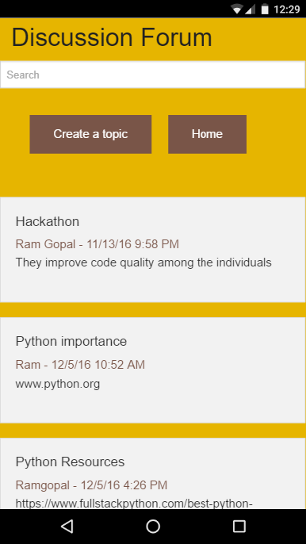

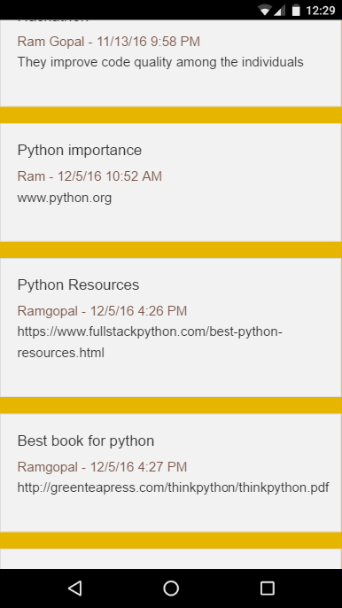

2.18 Any user can create post by clicking on ‘create a topic’ button.

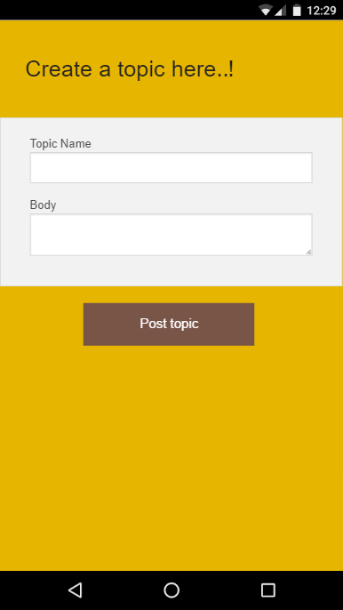

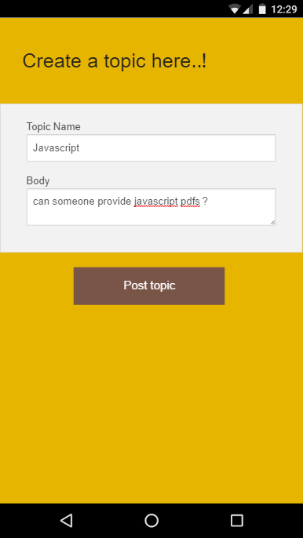

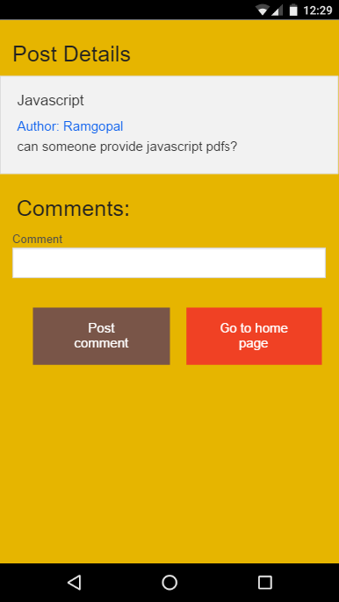

2.19 Any other user can comment on the existing post.

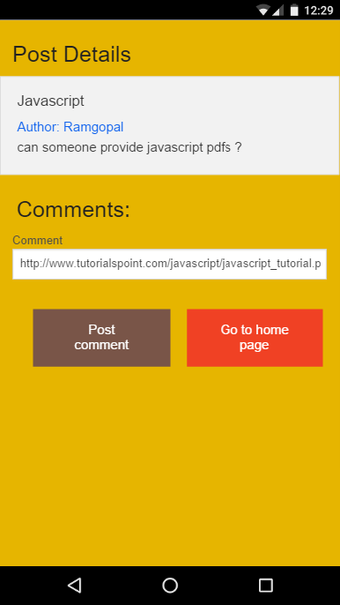

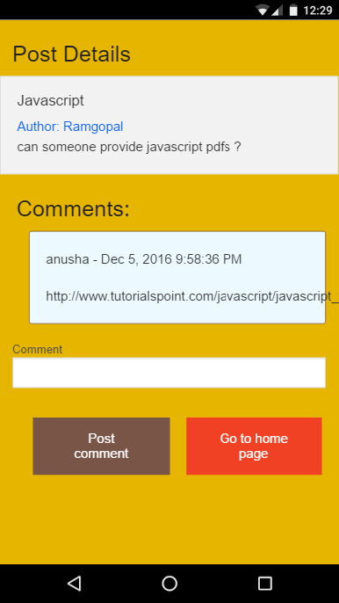

2.20 User can search for any existing post in the forum.

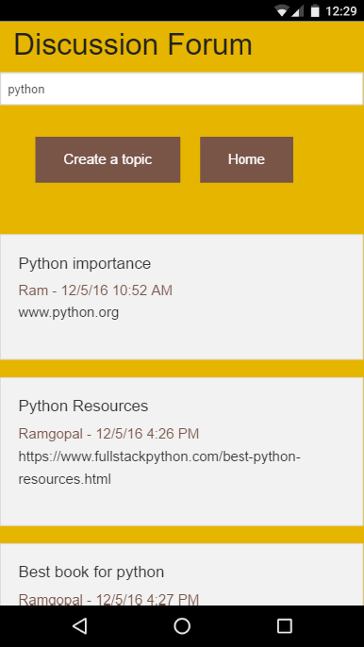

2.21 User can give feedback by clicking on ‘feedback’ button from the side menu.

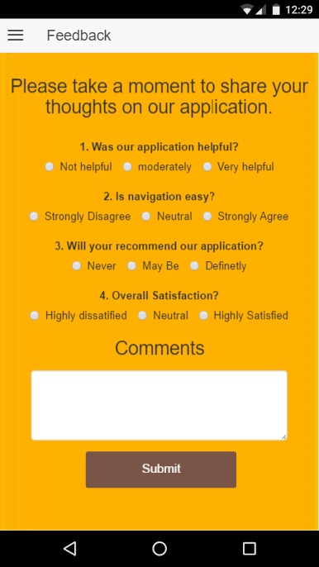

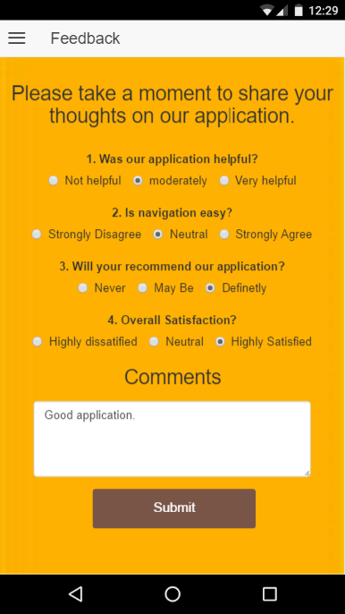

2.22 User will be redirected to settings page by clicking on settings button from

side menu.

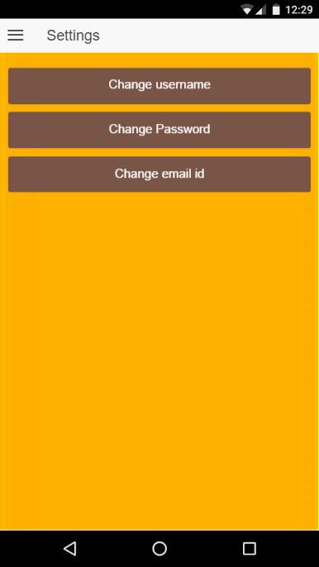

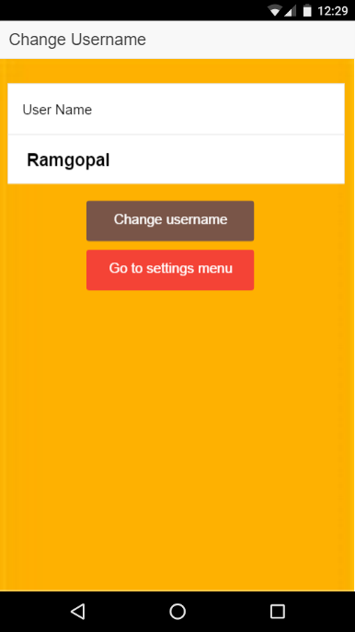

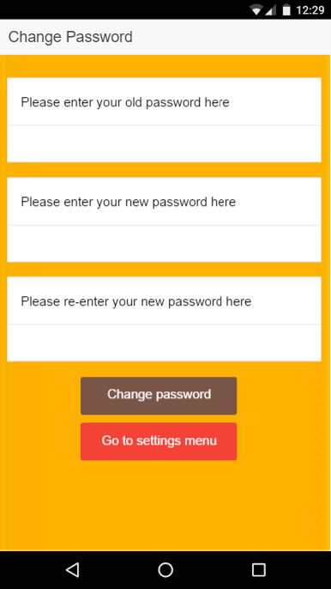

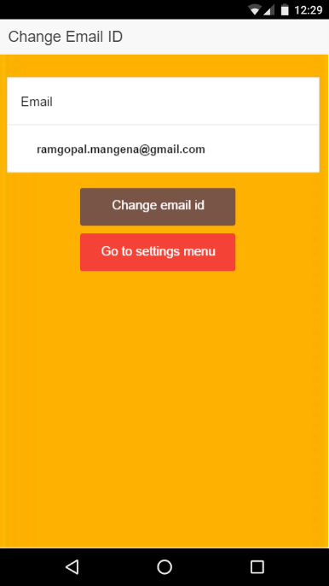

# Project Management:

Project Management Report:

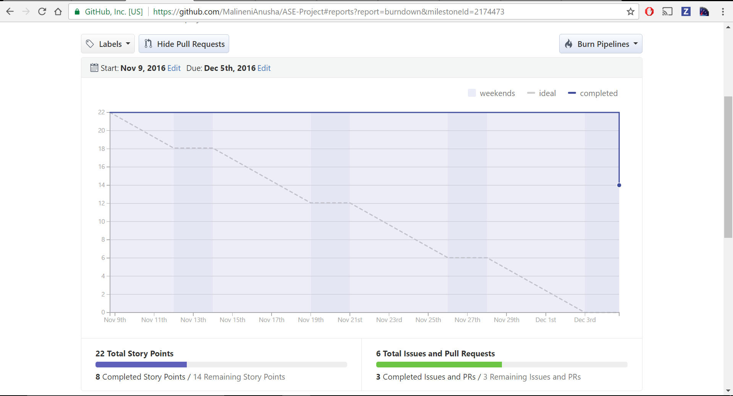

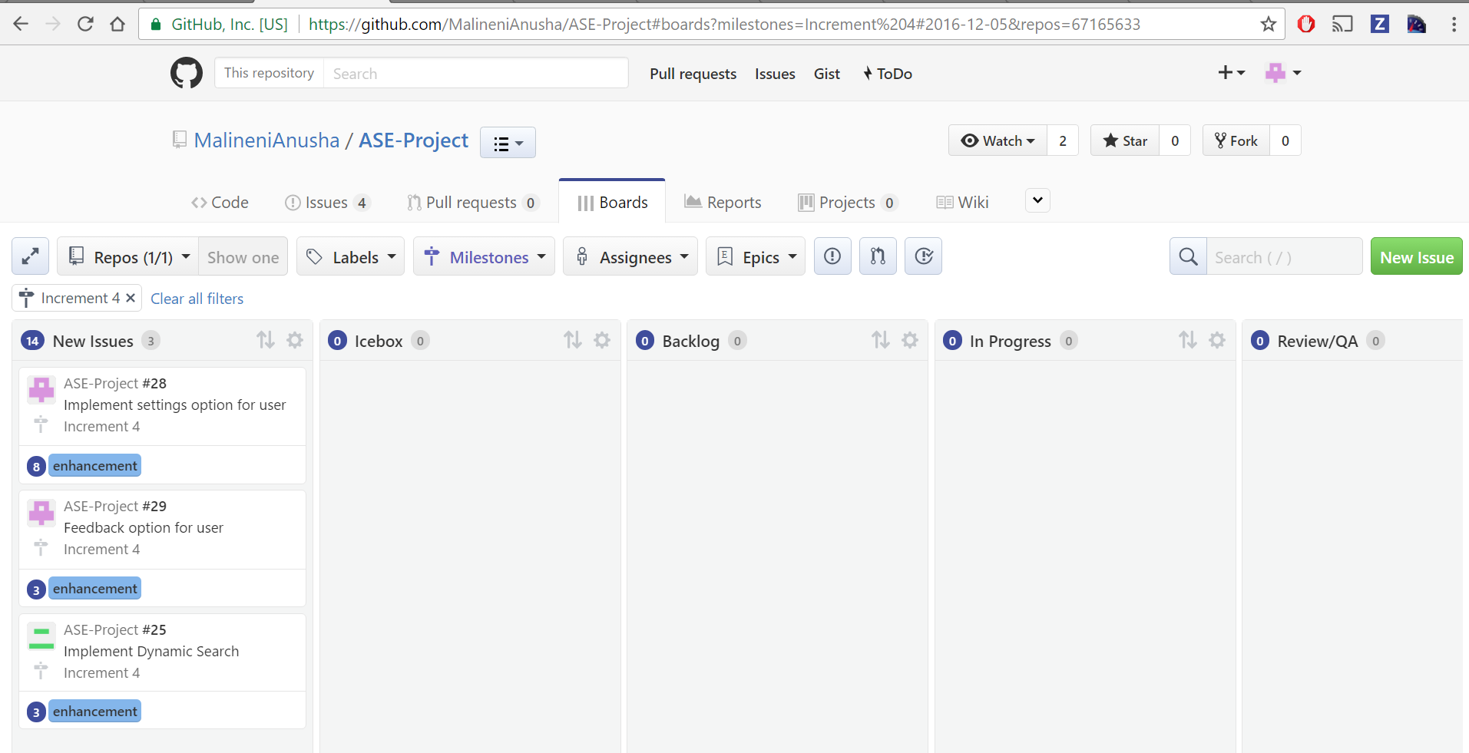

Final Project Evaluation:

We have started this project to enable the users to search for all the online resources using one app which includes video lectures, online courses information, Wiki pages, technical events in the location you searched. However, there are some backdrops in the project, where we tried to implement SlideShare API, we made it work for Android version, but when we changed the platform to Ionic we could not make it work, because of limitation of the API to platform, this could be mentioned as one of the challenges we faced. But we are satisfied with the design of our project which meets the requirement as it enables the user to search the online resources mentioned.

Agile process made our work easier when compared to other process models. Through Agile we can communicate seamlessly with brief meetings. This enabled us to work quickly towards the requirements.

# 3. Project proposal

**3.1 Overall goal:**

Main goal of this application is to provide all the available sources like wiki pages, videos, online courses, events and can discuss about any technical matters with any other users of the application.

## 3.2 Specific objectives (problem statement)

3.2.1. To create a unique platform where the users can get all the available resources related to any course in the field of computer science.

3.2.2. By searching for a specific course, this application will retrieve available resources in the form of videos, wiki pages, online courses and events.

3.2.3. Maintaining a discussion forum where users can discuss about any technical updates among themselves.

## 3.3 Specific features

**3.3.1 Search for Wiki’s:** This feature enables the user to search topics on Wikipedia related to any course.

**3.3.2 Search for videos:** This feature enables the user to search for top videos related to any course.

**3.3.3 Search for events:** This feature enables the user to search for any technical events near to the given place.

**3.3.4 Search for online courses:** This feature enables the user to search for available online courses related to any course.

**3.3.5 Discussion forum:** User can discuss among themselves regarding any technical topics and any other user can reply to the existing post.

**3.4 Significance**  The application provides the wide range of resources like

videos, wiki pages, online courses, technical events at a single point.

# 4.Project Plan

**4.1 Class Diagram:**

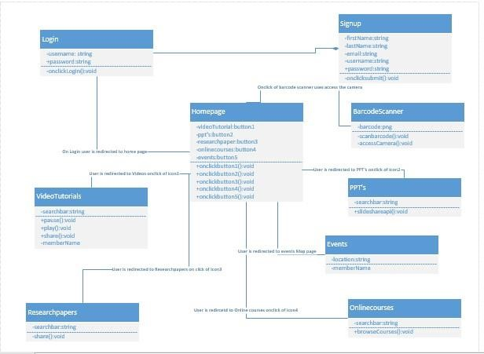

**4.2 Use Case Diagram:**

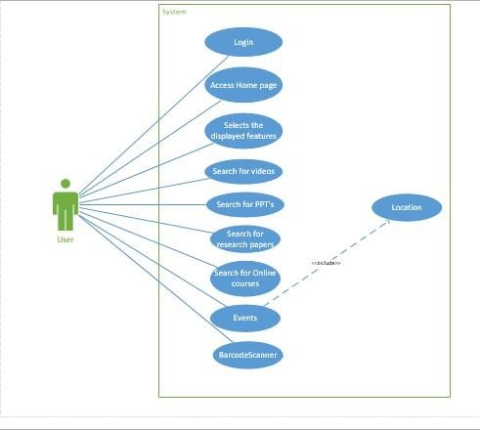

**4.3 Sequence Diagram**

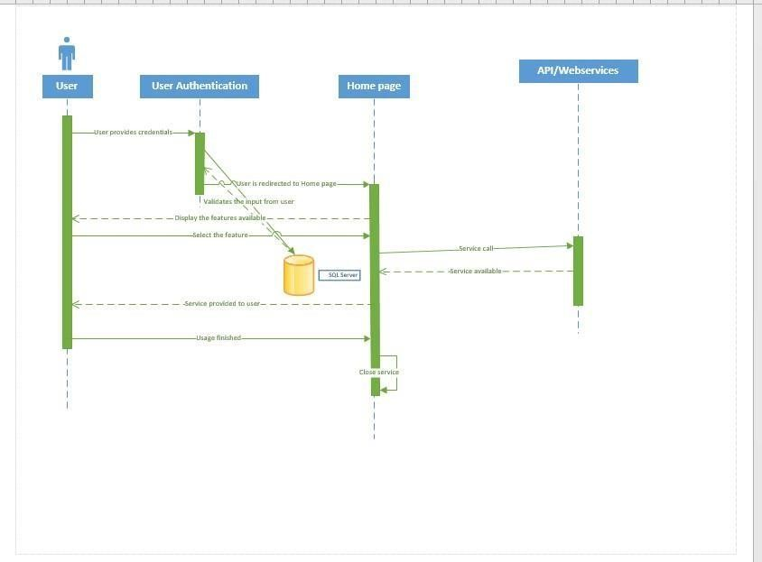

**4.4 Architecture Diagram:**

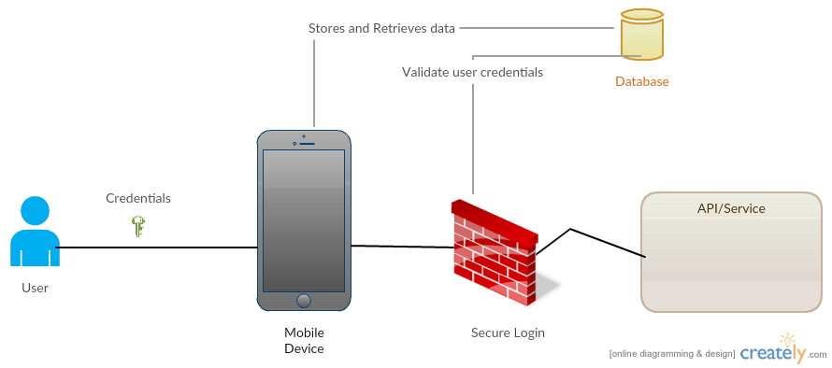

**5. First Increment Report**

**Implementation:**

In the first increment, we have implemented the following features.

* Login page
* Registration page
* Facebook OAuth login
* Home page

We have implemented these features in android using android studio.

**First increment report:**

https://github.com/MalineniAnusha/ASE-Project/blob/master/Documentation/Project%20Plan%20and%20Increment%201.pdf

**6. Second Increment Report**

**Implementation:**

In the second increment, we have implemented the following features.

* SlideShare API
* Eventful API
* Bar code Scanner
* Improvised the user interface of home page, login page and registration page.

We have implemented these features in android using android studio.

**Second increment report:**

<https://github.com/MalineniAnusha/ASE-Project/blob/master/Documentation/ProjectSecondIncrement.pdf>

**7. Third Increment Report**

**Implementation:**

In the third increment, we have developed the application in ionic framework. Because of dependency issues in android, we have moved our application to ionic framework.

* YouTube API
* Eventful API
* Wiki page
* Profile Retrieval
* Mongo DB integration
* Integrated login and registration with MongoDB.
* Improvised the user interface of the application

**Third increment report:**

<https://github.com/MalineniAnusha/ASE-Project/blob/master/Documentation/Project%20Third%20Increment.pdf>

**8. Fourth Increment Report**

**Implementation:**

In the fourth increment, we have implemented the following features

* Integrated Discussion Forum with application
* Search mashup for YouTube and wiki
* Integrated firebase with discussion forum
* Feedback from user
* Settings that include reset options for user details.
* Improvised the user interface of the application.

**Fourth increment report:**

<https://github.com/MalineniAnusha/ASE-Project/blob/master/Documentation/Project%20Fourth%20Increment.pdf>

• **Test Cases for Login and Signup page:**

|  |  |  |  |
| --- | --- | --- | --- |
| **Case** | **Test case Description** | **Expected Result** | **Actual Result** |
| Login | Enter invalid username and password | Error message should pop up saying invalid credentials. | PASS |
| Login | Enter invalid username and valid password | Error message should pop up saying invalid credentials. | PASS |
| Login | Enter valid username and invalid password | Error message should pop up saying invalid credentials. | PASS |
| Login | Enter valid username and password | Page should redirect to Home page | PASS |
| Signup | Email id format should end with @mail.com | Give error message incorrect email id format | PASS |
| Signup | Password of length 8 characters | Gives error message password is weak | PASS |
| Signup | Password and confirm password should match | If this succeeds it redirects to login page | PASS |
| Eventful | On searching the location | Display the nearby events | PASS |
| Youtube | On searching for the videos | Display list of videos related to search word | PASS |
| Wikipedia | On searching the content on the wikipedia | Displays list of topics related to search results | PASS |

**GitHub wiki page URL**:

[https://github.com/MalineniAnusha/ASE-Project/wiki/Project-Final-Increment](https://www.google.com/url?q=https%3A%2F%2Fgithub.com%2FMalineniAnusha%2FASE-Project%2Fwiki%2FProject-Increment-4&sa=D&sntz=1&usg=AFQjCNEddNt-OBmYQBEt052daZWSY2a9AA" \t "_blank)

**YouTube URL:**

<https://www.youtube.com/watch?v=XqjHIozLcoc&feature=youtu.be>

# 9. Project Management

## Implementation status report

**Technologies Used:** Ionic Framework, HTML, CSS, JS, Angular JS.

**Work Completed**

* Design and Architecture of the Application
* Login and Registration using Mongo DB.
* Implemented on Eventful API
* Implemented YouTube API.
* Implemented Coursera API.
* Implemented Wiki search API.
* Implemented search mashup.
* Integration firebase in discussion forum.
* Improving the User Interface of the application.
* Implemented discussion forum in application.

**Contributors:**

|  |  |  |  |
| --- | --- | --- | --- |
| **Achyuth** | **Sujitha** | **Ram Gopal** | **Anusha** |
| YouTube API to retrieve the list of videos. | Wikipedia API to retrieve data from Wiki. | Coursera API to retrieve coursera details. | Eventful API to retrieve, technical events in the location |
| App Login & Facebook Login | Search mashup results from YT & WIKI. | User registration module. | User profile retrieval |
| UI for login page, Registration page. | Reset enable in settings | UI for Home page & other pages | Feedback module |
| Retrieval of data in Discussion forum. | Discussion forum search functionality. | Discussion forum firebase integration & module to post a discussion | Discussion forum, post comment from another user module |

**10. Future Work**

* Could add Journal papers related to the topic search, which can be rendered as

feeds in the app based on the search keyword.

**11.Biblography**

* <http://stackoverflow.com/>
* <https://forum.ionicframework.com>
* <https://developers.facebook.com/>
* <https://developers.google.com/youtube/>
* <https://github.com>